String Notes

1. In Java String is a Class. The String class provides the different methods supports.
2. Java String is an immutable and for storing the string literals there are the string constant pool.
3. In there are three classes for handling the character data.

* String
* String Buffer
* String Builder

1. String is immutable and String Buffer, String Builder is mutable.

Why Java Makes the String immutable?

* In real world use the most of the data in the form of the string. So for manage the memory efficiently the java use the concept object data sharing.
* Ex. Suppose there are the different object present O1,O2,O3,O4… O9.
* Object represents the persons here, every person belongs to Mumbai and they share the data between us.

String Str1= “Mumbai”

String Str2=”Mumbai”

….

…..

……

…….

String Str9=”Mumbai”

S2

S3

S1

**Mumbai**

**SCP**

In SCP the reference pointing to the same data Mumbai.

Suppose we want to change the s3 data Mumbai to Bangalore.

If we write s3=” Bangalore” so now every reference start pointing to the Bangalore because data was changed!!!

This is the reason java make the string constant, for every new and different data java create the new objects. And save the memory efficiently.

String s4=” Bangalore”

String s5=”Bangalore”

**Bangalore**

S4

S5

S3

S2

S1

**Mumbai**

String Buffer and String Builder are the mutable classes. Both the class have the same methods but the only difference it’s the String Buffer class methods are synchronized methods.

And String Builder class methods are non-synchronize methods.

The String Buffer are thread safe and String Builder are not thread safe.

And for the string class is not need any synchronization because its immutable.

Basic Questions

Q1. Count no .of alphabets, character and special characters.

Solution:

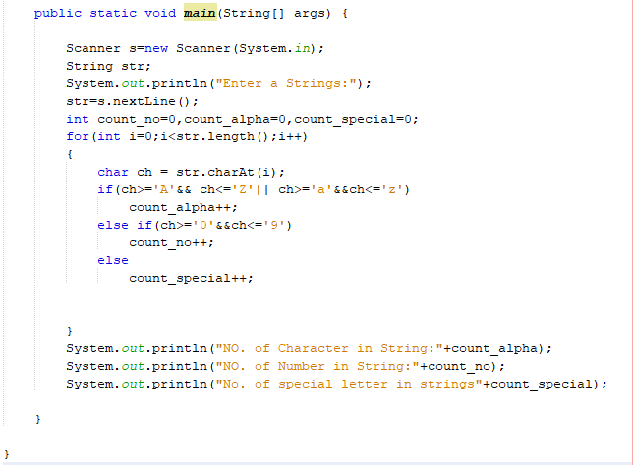

Output:

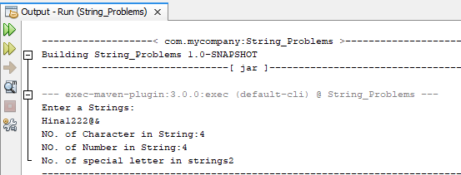

Q2. Count the frequency of the character in the string.

Solution:

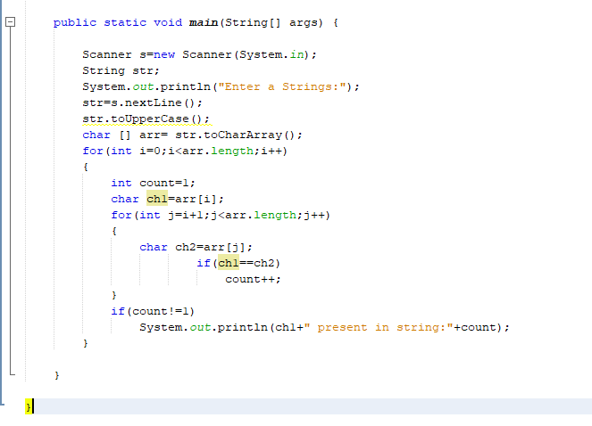

Output:

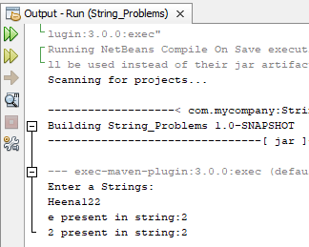

Q3. Find the Given Strings are anagram string or not.

What is anagram string?

* The diffrenerent two strings are with the same size and with the same no. of characters.

Solution:

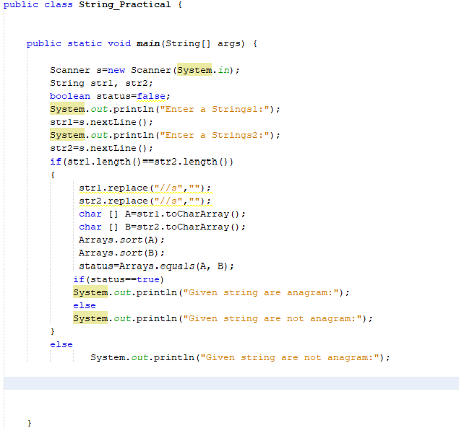

Output:

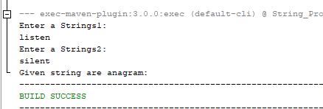

Q4. Reverse the String

Solution:

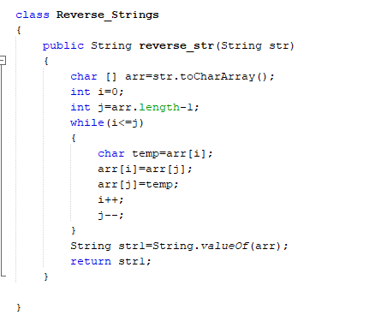

Output:

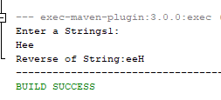

Q5. Check the Palindrome String

Solution

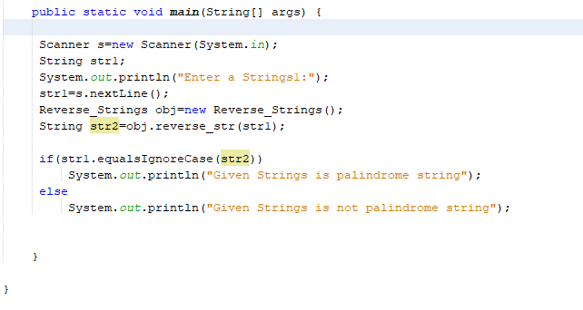

Output:

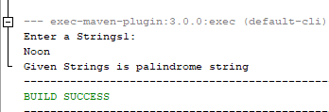

Q Print the new Character on the new line, new word first character is in capital letter

Solution:

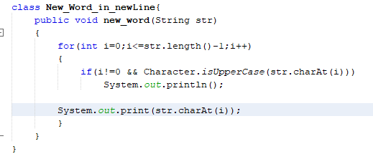

Input:

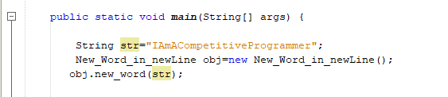

Output:

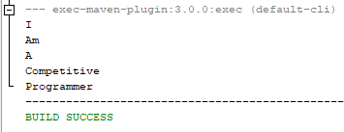

Q Find the Maximum Frequency of character

Solution:

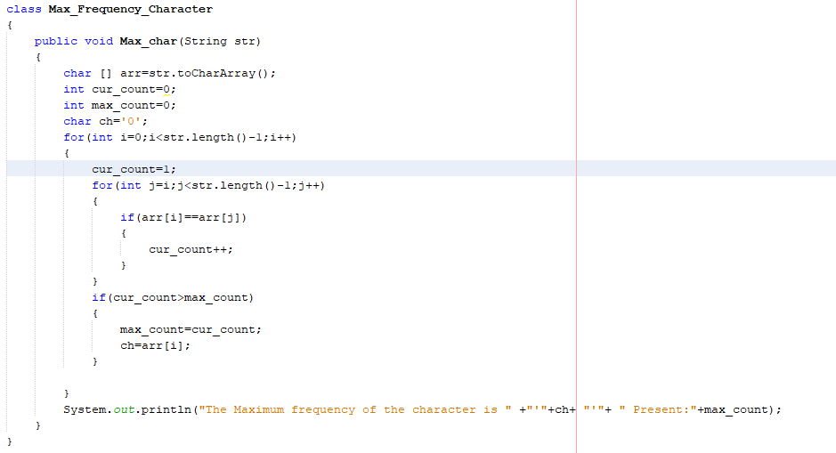

Input:

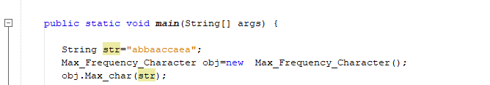

Output:

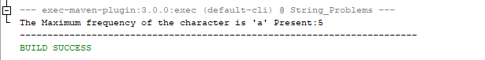

Q. Comparing two string if character different printing 1 else 0

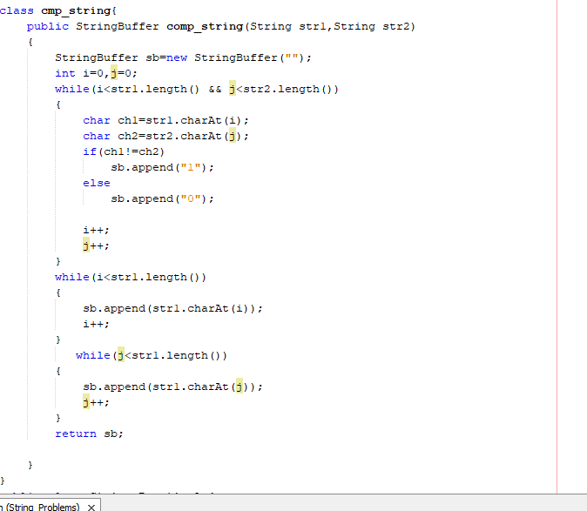

Input:

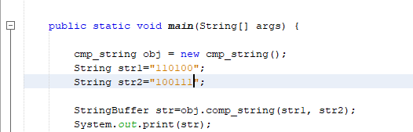

Output:

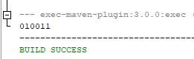

Q. Piyush Magical Park problem.(Coding Blocks)

Everything clearly mention in the problem statement. See that first easy one.

Solution:

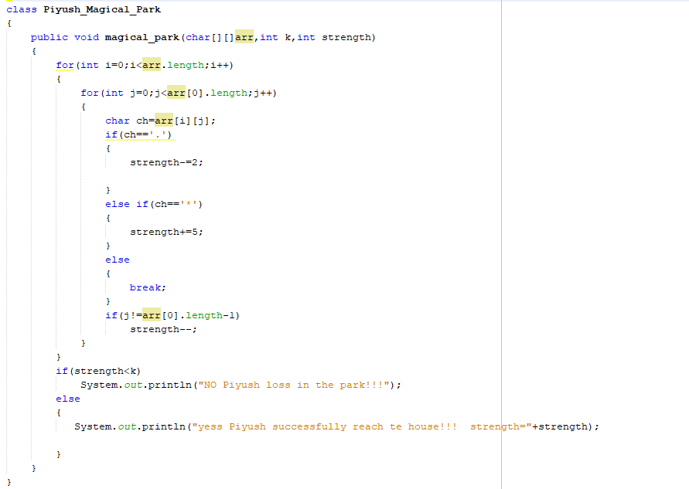

Input:

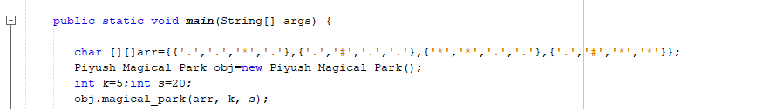

Output:

